# Project Capability - Aurecon Align Project Functionality Reuse Review

## Projects Schema

The schema for Aurecon Align project functionality

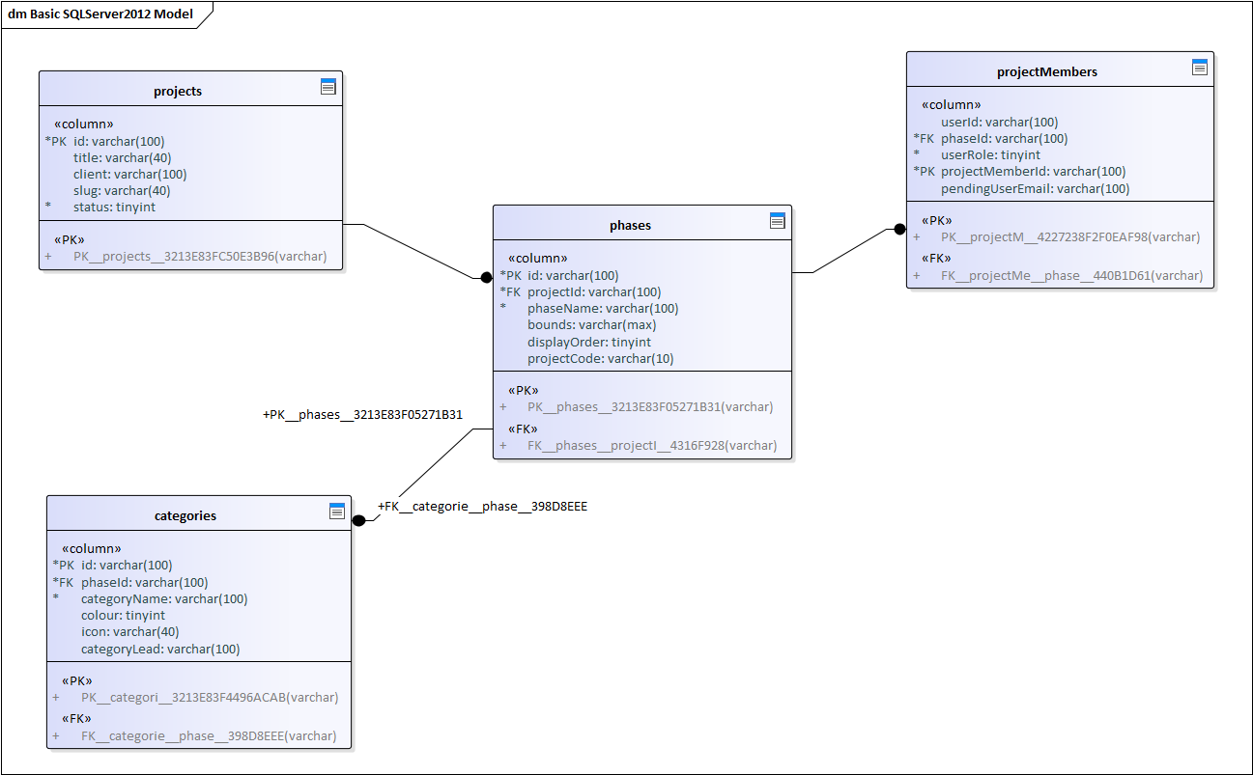

For GPC it may make sense to present Phase as ‘Project’ and Project is ‘Project Group’.

What this supports and makes direct sense for GPC

* Many projects
* Many members
* A project status
* categories

What this supports and should be ok for GPC

* Many phases for projects (a 2 level structure when they only need 1)
* Members associated to phase
* A client for projects

What this supports but doesn’t make sense for GPC

* Phase Bounds
* Phase displayOrder

Comment…these ideally exist in a related property table

* Category Lead

Action: Don’t implement into capabiltiy

What is missing from this for GPC

* A set of roles …GPC wont have roles from OAuth so we need to have them.
* Use operated to create the project and last change ….these can be added

Action: Add role into DB which is GPC specific table not a capability table

Proposed Schema for Project Capability

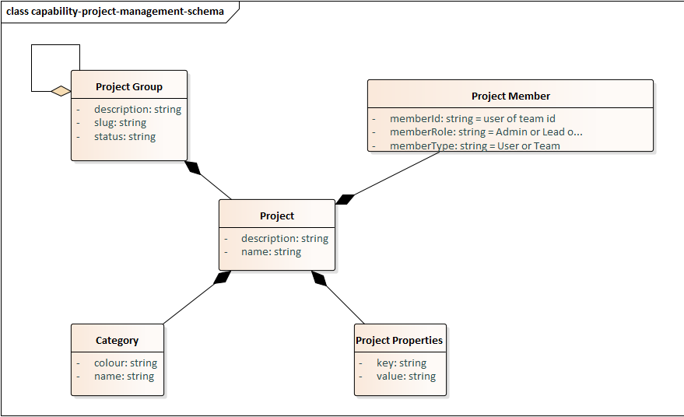

## User Interface

### Project List View

There is a project overview page which could have value for GPC.

Align UI

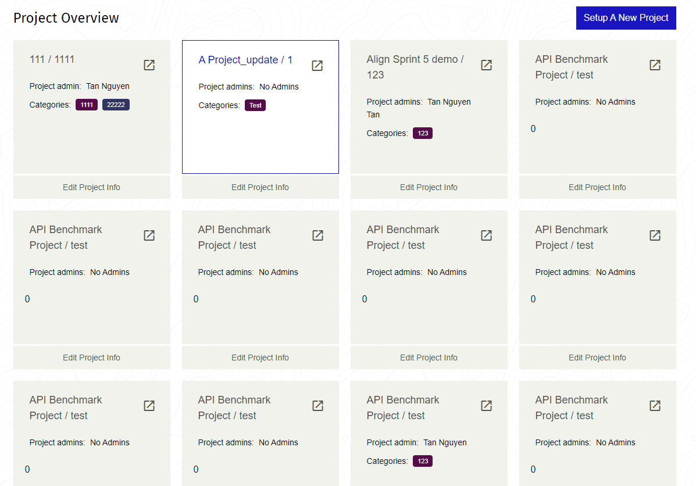

Equivalent GPC View

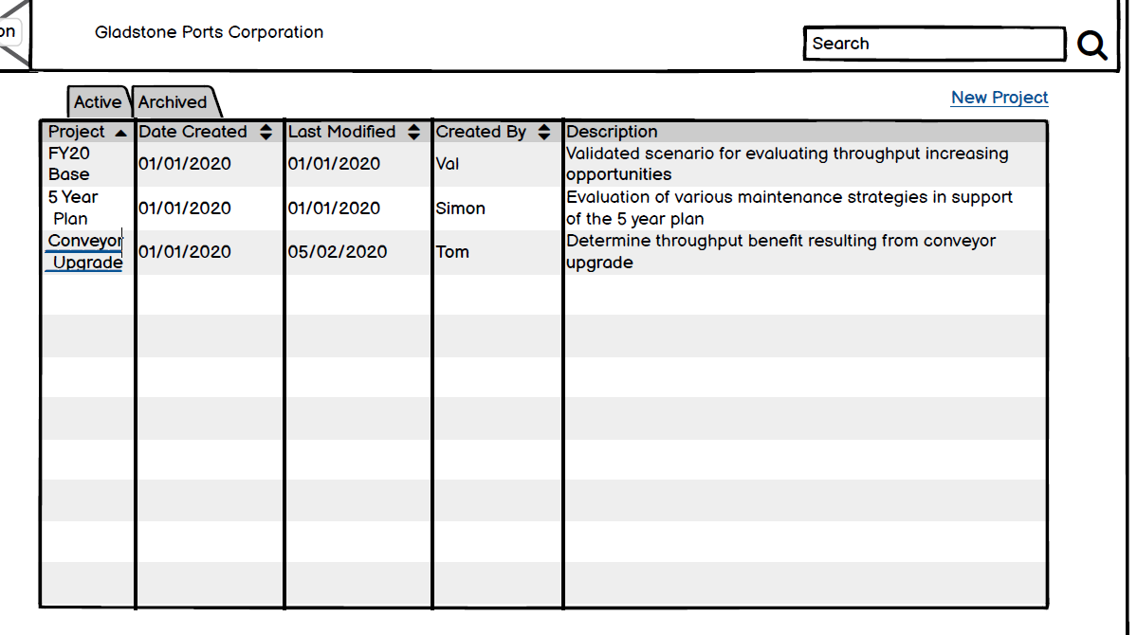

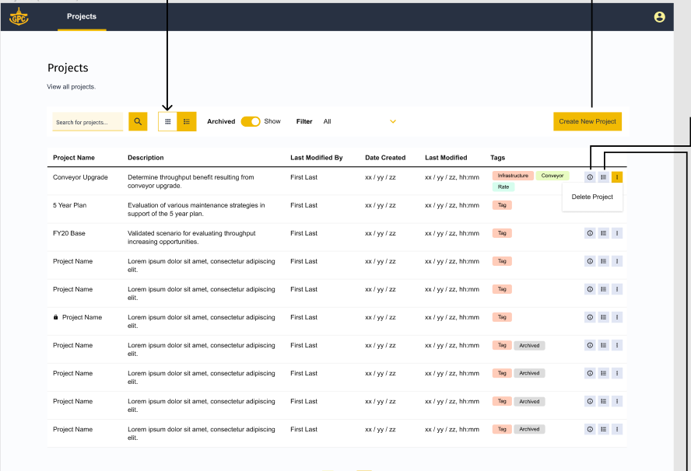

What this supports which has value for GPC

* Control to create new project
* Project Summary Control
* Project Search

What this provides and might make sense for GPC

* Listing of project as tiles

What this support and doesn’t make sense for GPC

* Specific fields being surfaced on project summary tile

*Action: Capability to allow configuration of which fields are surfaced*

What is missing from this for GPC

* *Action: Add search into capability*
* Project/Phase.Description
* *Action: Add description*

#### Proposed Capability Components

What are the shared components here:

* A project creation control
* A project summary control
* A search control

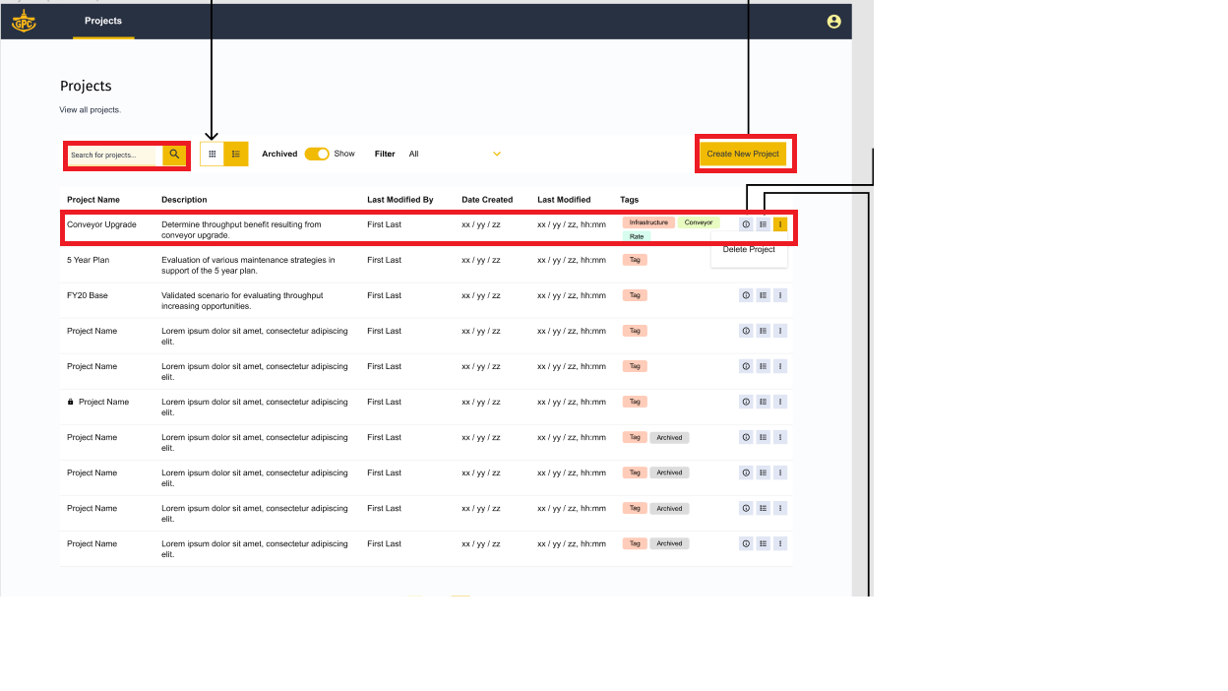

#### Reuse from Align

Need to split up some components

The search control and the sort filter should be separated so we can use one without the other.

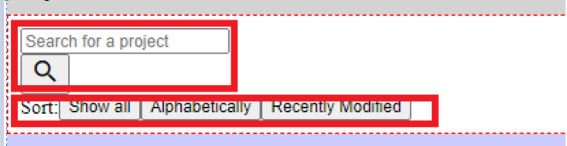

### Project Create/Edit Viewpoint

The project setup page is probably too complex for GPC.

Algin Version

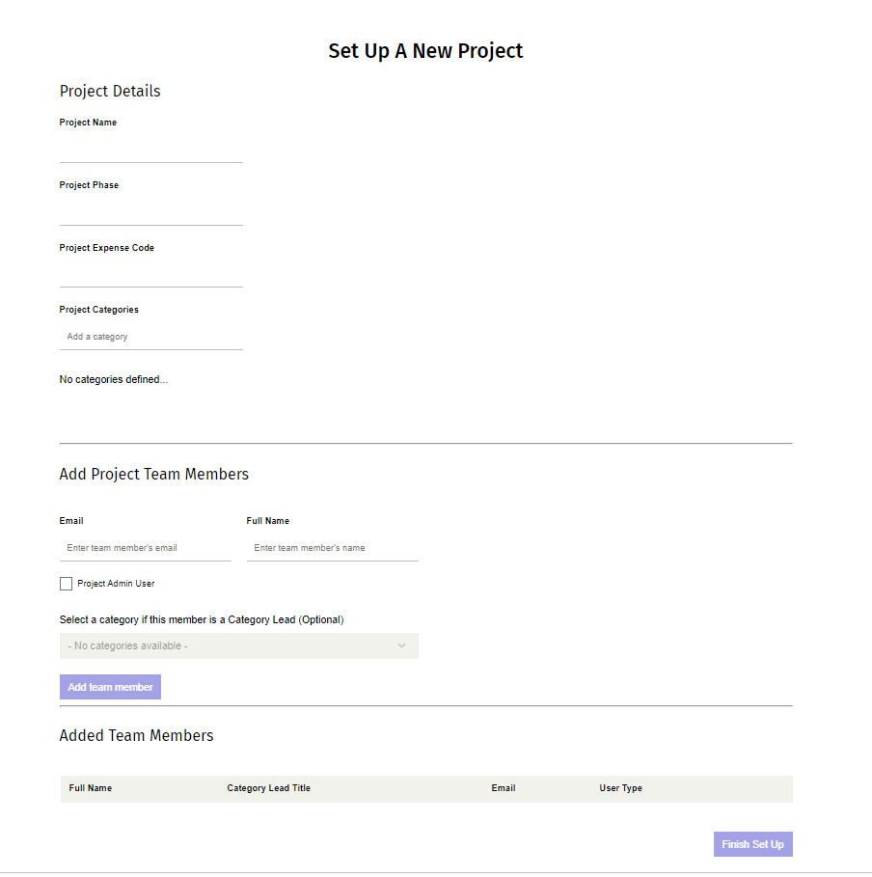

GPC Version

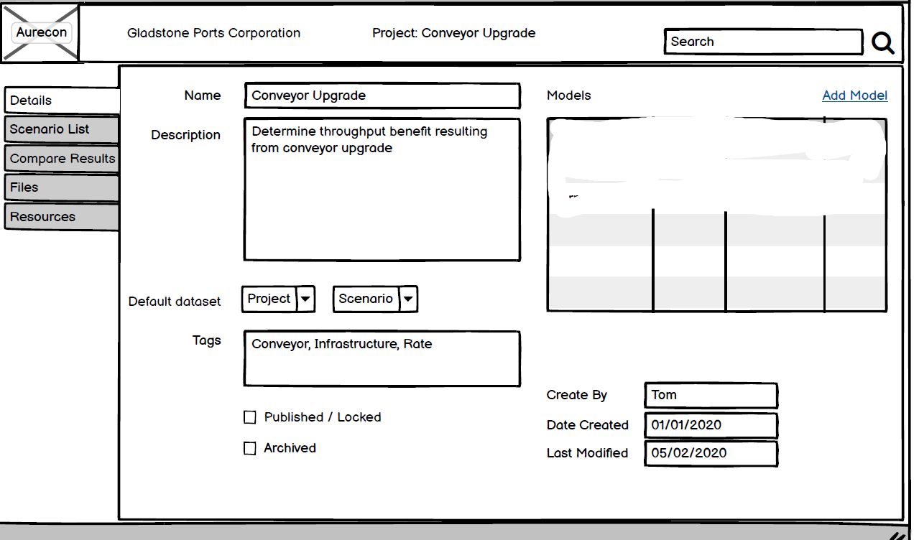

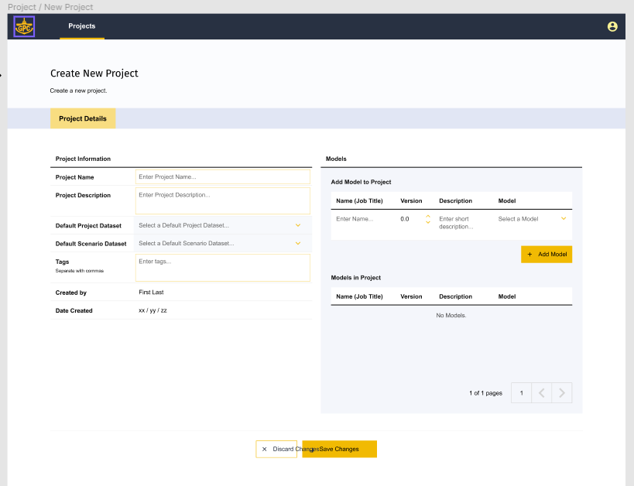

What this provides and might make sense for GPC

* Categories creation

What this support and doesn’t make sense for GPC

* Project Team member addition/removal

*Action: Clarify how different people get access to GPC projects*

What is missing from this for GPC

* Publish/Locking
* Archiving
* Default Dataset/Scenario
* Action: Add Publish/Lock and Archive to capability
* Action: The relationship to scenario is GPC specific and should go into a Properties table

#### Propose Capability Shared Components

* A project save control
* A project cancel control
* A project name control
* A project description control
* A project tags control
* A project createdBy
* A project date create control

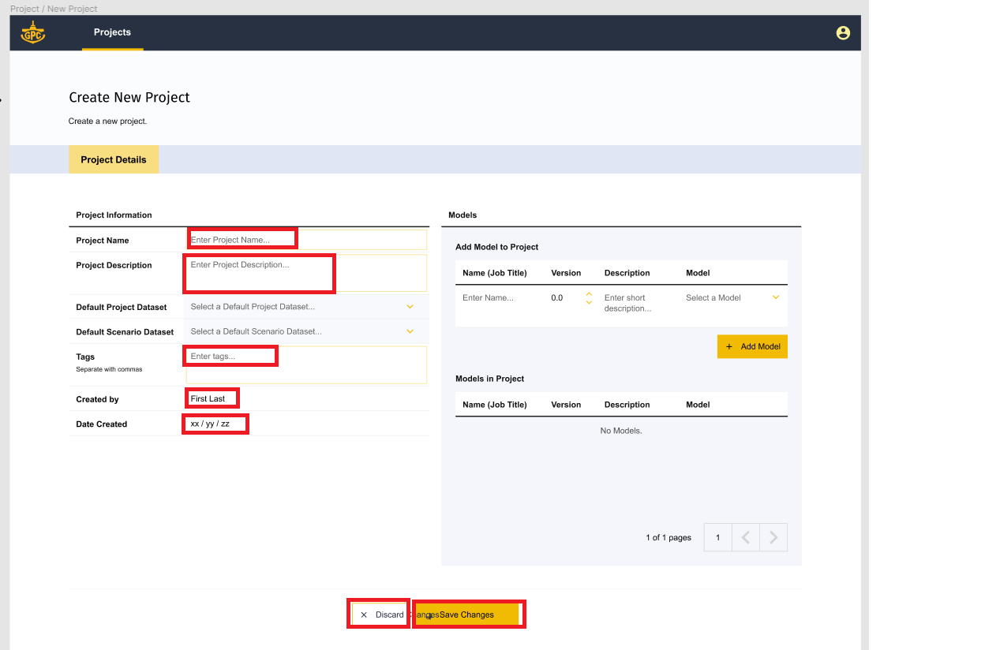

## How to Migrate

Create models to reflect schema above

Migrate server routes from Align code base where appropriate

Categories.js, projects.js

Migrate client pages to shared components

MyProjects, SearchMyProjects, ProjectsTileView, …..